**Web Push Notifications for Hybris**

Web push notifications are **Off-Site browser Notifications.** (Alerts you on your desktop or device, even when the website is not open on

your browser)

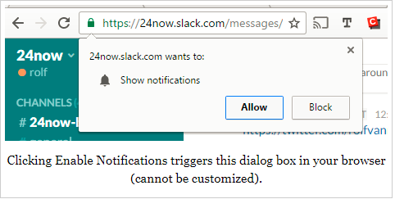

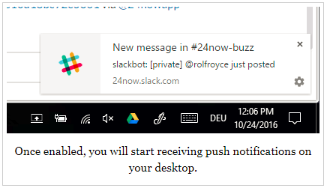

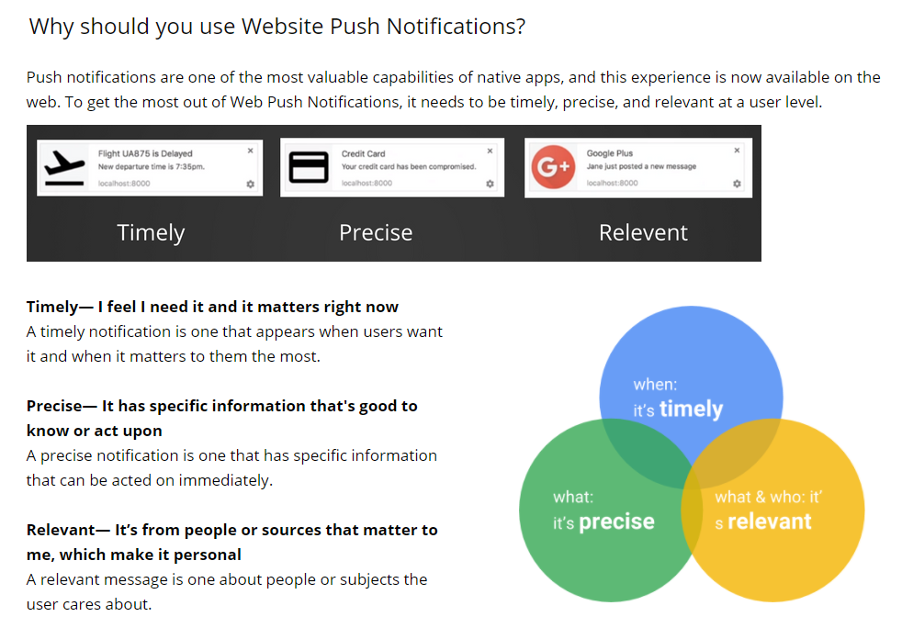

**Actions that could trigger push notifications**

* Breaking news (for example: Michael Jackson died, Pope outed as gay, etc.)
* Live events starting
* New offer available / back in stock
* Important travel information (flight canceled, bookings changed)
* New product / service feature available
* New awesome blogpost online

And many more as per the scenario and customer requirements

## **Benefits of using web push notifications**

* Push notifications can serve as a great customer retention tool. It helps us engage customers more.
* This new marketing channel helps re-engage your site visitors without intruding upon their privacy, or requiring them to submit their email and other contact details.All that the user needs to do is to subscribe to notifications.which ultimately result in high opt-ins.
* Users do not have to install an app to get notifications.
* Web Push Notifications work with the same degree of precision and quality across different devices, platforms and browsers.

Few samples are as follows:

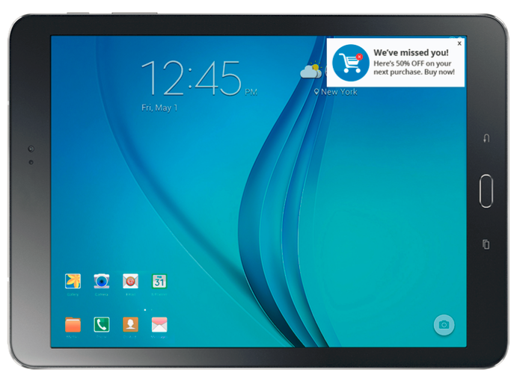

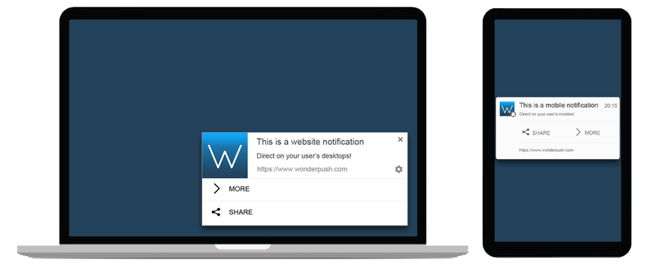

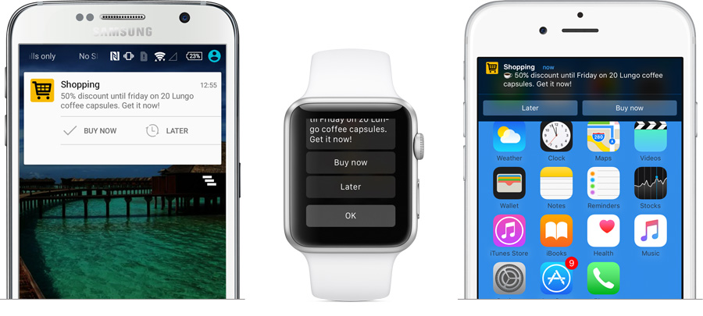

* Push notifications provide many options to tweak the look and feel based on user requirement.
* Browser notifications can be triggered regardless of whether the subscriber is on/off page or browser is closed/open.
* Adaptability and reach are also guaranteed as Web Push Notifications already work on over 85% of devices.
* Assured content delivery.
* Conversion rates are higher by 30 times compared to E-mail.

Personalized notifications Images??

Our implementation provides a backoffice widget where in we can compose a notification by providing the title, description and the link wheerin you want to redirect the user to once s/he clicks on the notification.

In backoffice, click on the push notification node in the explorer tree on the left hand side and enter the title , description and link and click on SEND.

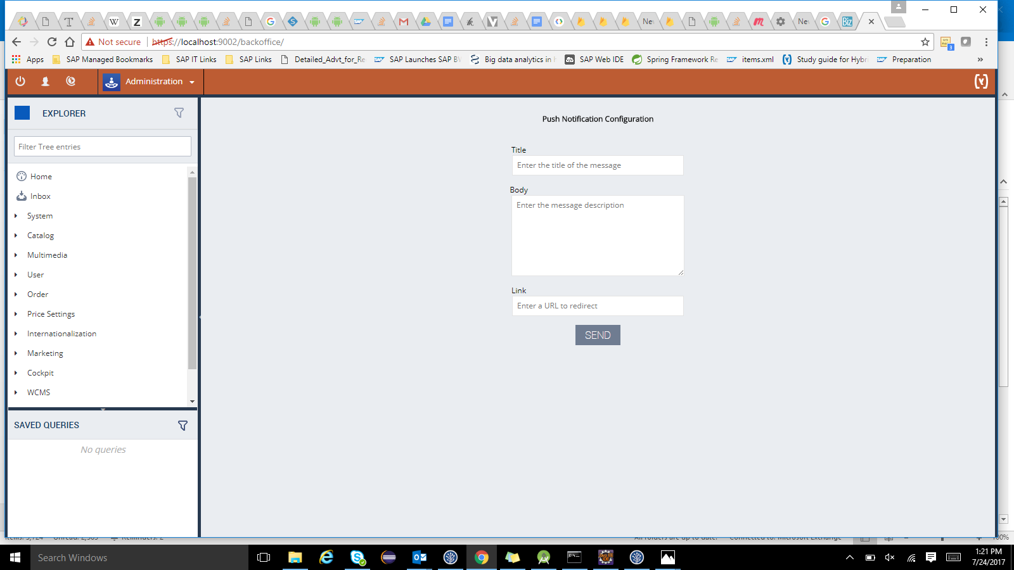

If the tab in which our website is open is out of focus(or even if the browser is closed), we will get a notification like:

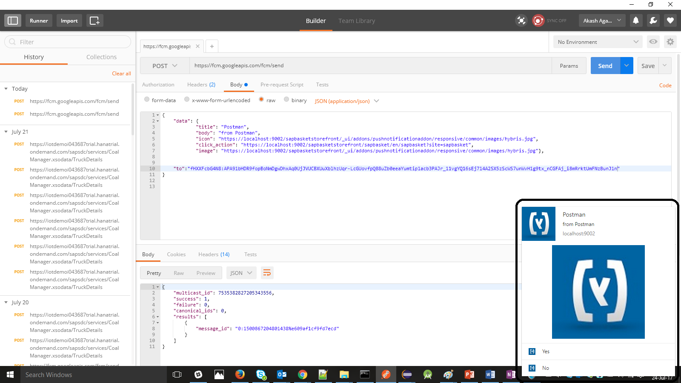

**Extensibility Options:**

* Customer-specific notifications(**User Segmentation**).
* **CronJob(s) to automatically send notifications** at regular time intervals or trigger at certain events.
* Can be used alongside **analytics** systems and correlate with business performance indicators trend
* Few **samples** are as follows:

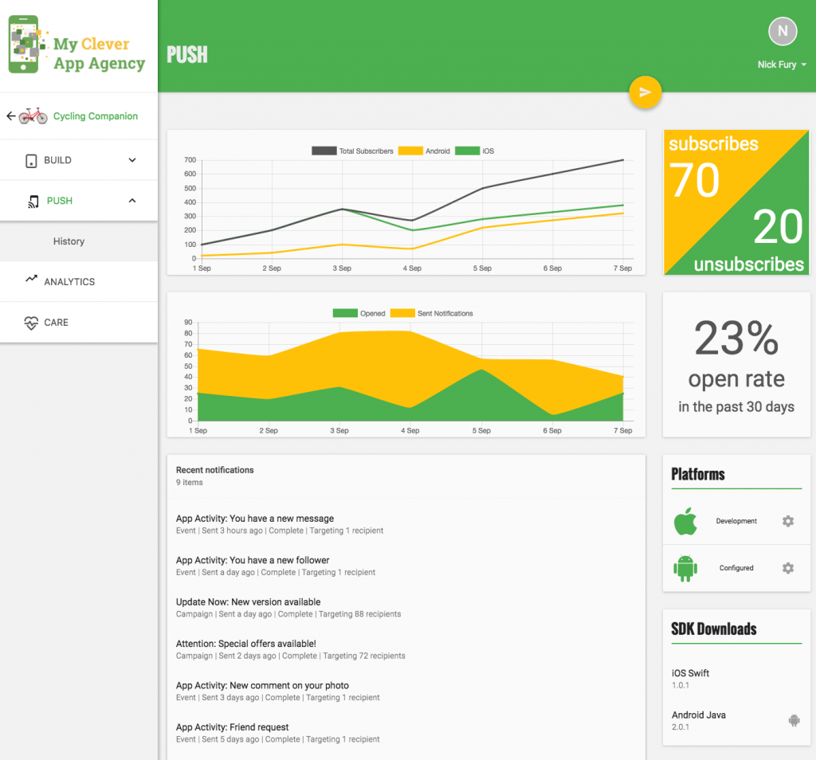

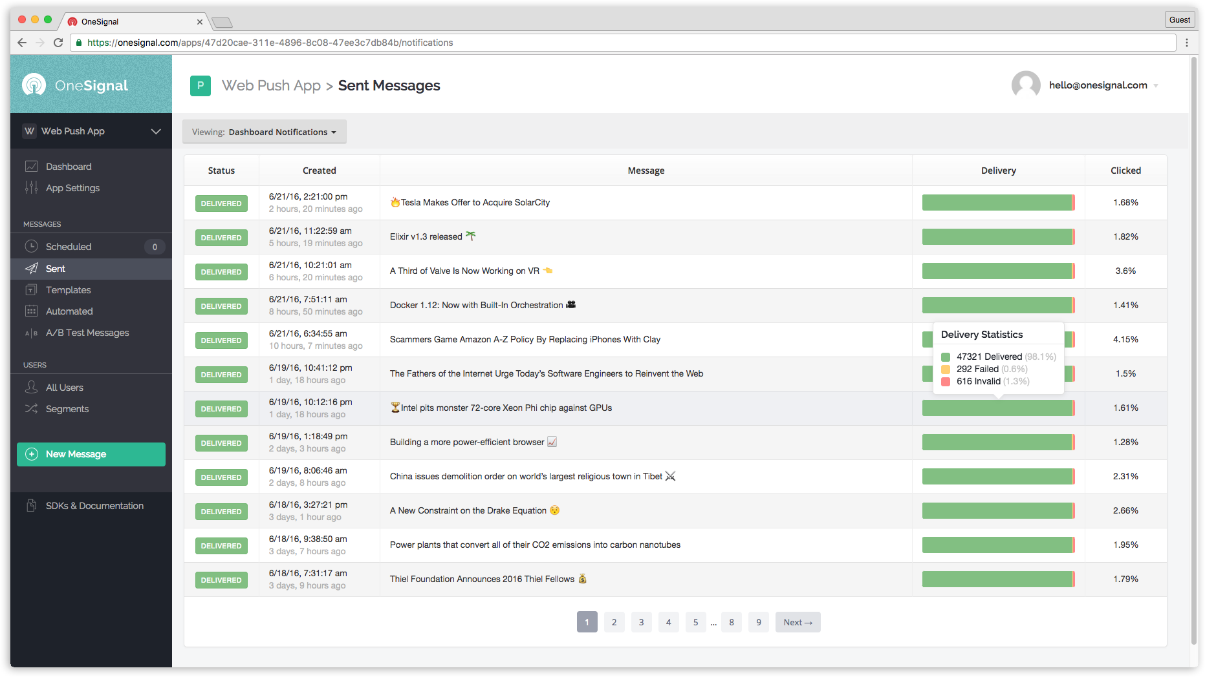

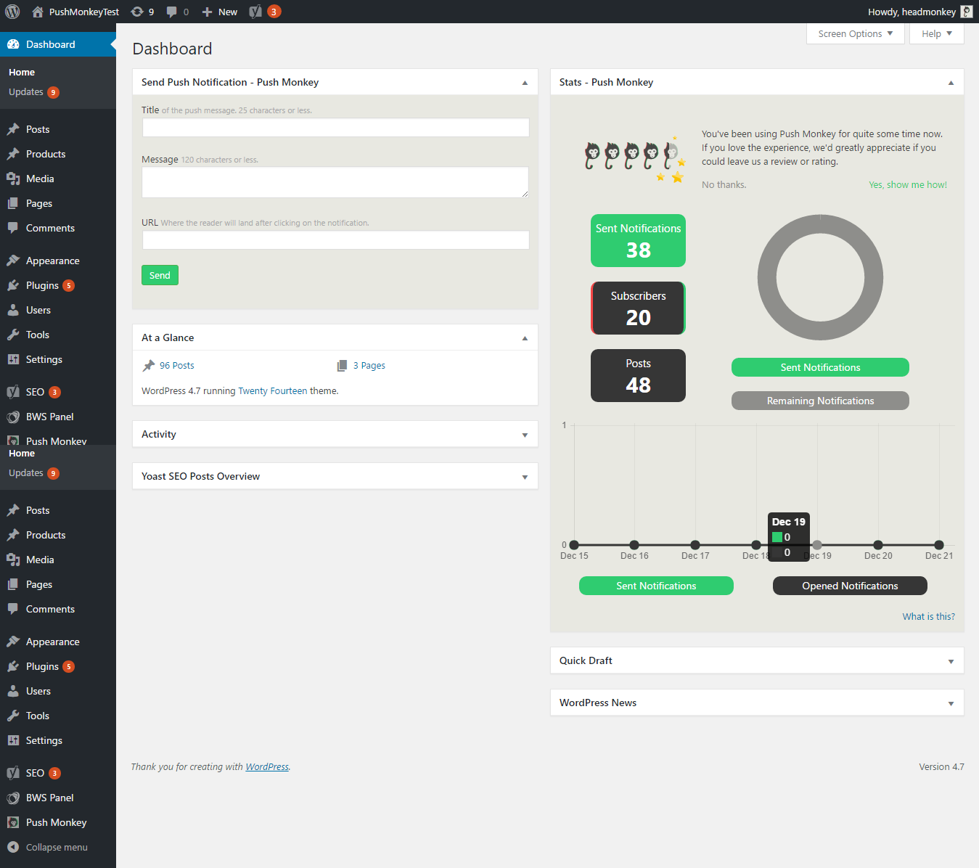

* Notifications can be customized to tweak the behaviour in different devices

Follow the links below for more customization options available

[**https://firebase.google.com/docs/cloud-messaging/http-server-ref#notification-payload-support**](https://firebase.google.com/docs/cloud-messaging/http-server-ref#notification-payload-support) and

[**https://firebase.google.com/docs/cloud-messaging/concept-options**](https://firebase.google.com/docs/cloud-messaging/concept-options)

From a notification that has just the title, it can range upto:

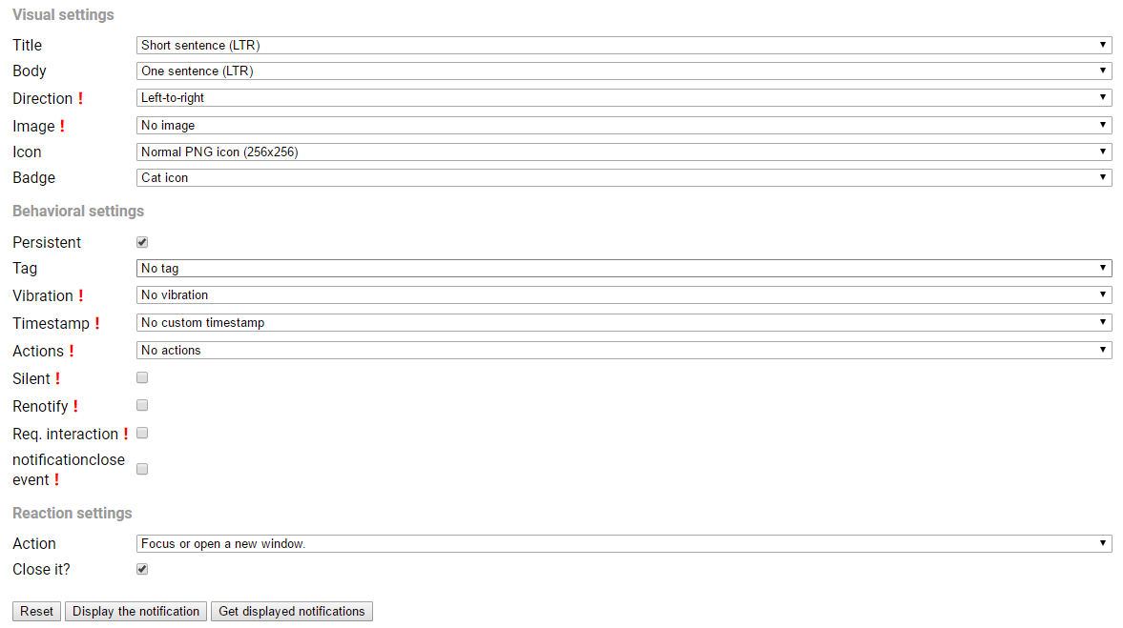

* Further, on clicking the “settings” gear icon on the notification pop up, we get a default page for push settings, like in chrome

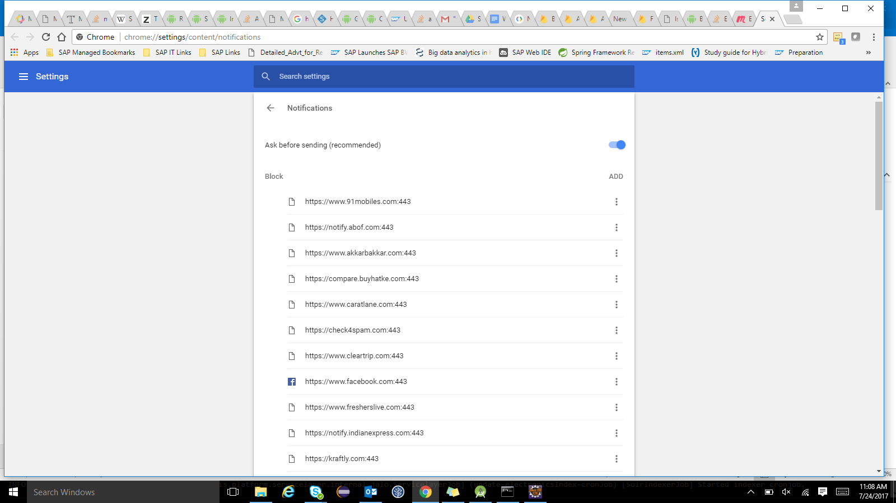

This can be further customized to provide more user specific options like subscribing to a specific sale, time slots to display notifications etc.. For example,

